EXPERIMENT 1
Generate Text Embedding and Perform Semantic Similarity Search
Name | P Nishanth
Register Number | 192472292
AIM
To convert text into numerical vectors and find the most similar document using cosine similarity.

PROCEDURE
- Import TfidfVectorizer and cosine_similarity from scikit-learn.
- Create sample documents and a search query.
- Convert the documents and query into TF-IDF vectors.
- Calculate cosine similarity between the query and each document.
- Display similarity scores and the most similar document.

PROGRAM
from sklearn.feature_extraction.text import TfidfVectorizer from sklearn.metrics.pairwise import cosine_similarity

documents = [
"Python is a programming language.",
"Machine learning uses data to make predictions.",
"Artificial intelligence makes machines intelligent."
]

query = "Tell me about machine learning"

vectorizer = TfidfVectorizer() doc_vectors = vectorizer.fit_transform(documents) query_vector = vectorizer.transform([query])

scores = cosine_similarity(query_vector, doc_vectors)[0]

print("Search Query:", query) print("\nSimilarity Scores:") for i, score in enumerate(scores):
print("Document", i + 1, ":", round(score, 3))

best_index = scores.argmax() print("\nMost Similar Document:") print(documents[best_index])

OUTPUT
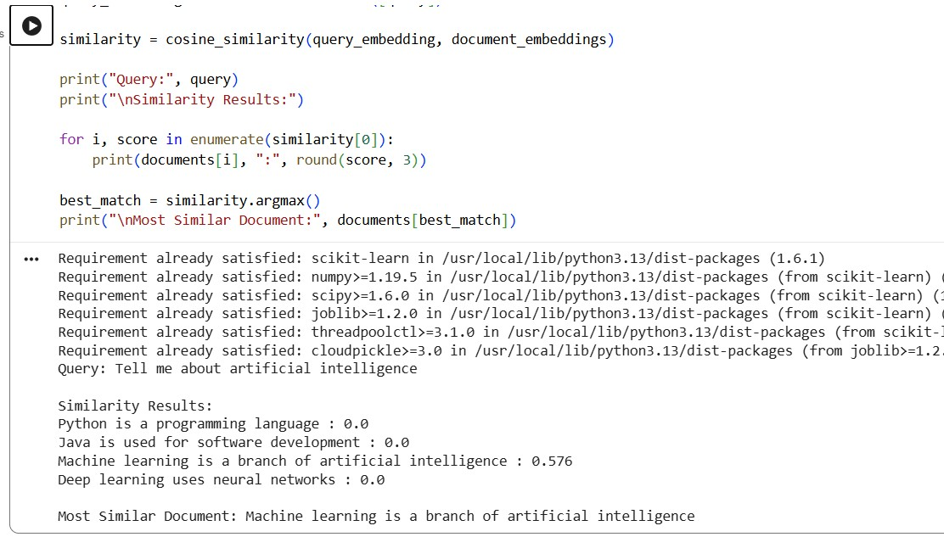

RESULT
Thus, text documents were converted into vectors and the most similar document was retrieved using cosine similarity.

